**AWS Quicksight- Learning Doc**

* **Workflow summary**

1. Add or upload a data source, and use it to create a new data set.
2. Prepare the data – get it available for reports by standardizing field names, or adding calculations, for instance.
3. Visualize and build new analysis from the data set.
4. Pick some fields to build the initial visual view in the analysis. One can utilize AutoGraph to dynamically make a visual dependent on the number and type of fields you pick. Alternatively, one can pick the visual type one wants to utilize.
5. Make changes to the visual(for instance, by adding a filter or changing the visual type).
6. Add more visuals to the analysis. One can resize and arrange them in the workspace.
7. Capture the analysis into a story to make a narrative about some part of the data analysis.
8. Publish the analysis as a dashboard to share insights with different users.

* **Setting-up quicksight**

1. Log into the console in the Cost Optimization account as an IAM user with the required permissions, go to the Amazon QuickSight console:
2. If you havent used QuickSight before click on Sign up for QuickSight, otherwise skip this step and proceed to Setup QuickSight IAM Policy below:
3. Select the Standard edition, and click Continue:
4. Select the region which should be the same as your CUR file source, Enter your QuickSight account name, Notification email address, select Amazon Athena and click Choose S3 buckets:
5. Select S3 Buckets One Can Access Across AWS, under Use a different bucket enter the CUR bucket name, click Add S3 bucket.
6. Click Finish.

* **Setup quicksight IAM policy**

1. Go to the IAM Dashboard
2. Click Policies and search for the AWSQuickSightS3Policy, click on the AWSQuickSightS3Policy policy.
3. Click Edit policy,
4. We will add the s3 resource arn:aws:s3:::cost* below the existing s3 bucket. This will allow Quicksight to access any S3 bucket starting with cost, so Cost Optimization users can easily create new datasets without requiring additional Quicksight privileges. Click Review policy:
5. Click Save changes.

* **Connecting data sources**

1. Navigate to the Amazon Quicksight main area. Select *Datasets* from the left-hand menu and click the *New Dataset* button.

* Give your data source a name be it Athena, Redshift, S3, SQL, Presto, Snowflake etc
* In case of RDS, select your instance
* Select the VPC connection.
* Enter your database name, username and password, these are the settings used to connect to the actual database on the instance.

1. Once your connection is validated, click Create data source to see a preview of the tables in your database.
2. If you just need data from a single table, you can choose the table and click Select. However, if you need to join tables, or format certain data fields before visualizing it, you can select one of the other options:

* Edit/Preview data – Takes you to the “data workspace”, a visual representation of the data entities
* Use custom SQL – This takes you to an SQL editor where you can write a query to pull out the data that you want.

If you’re already familiar with SQL, it to choose the custom SQL option, especially if your dataset requires a more complex query.

## **Option 1: Use custom SQL**

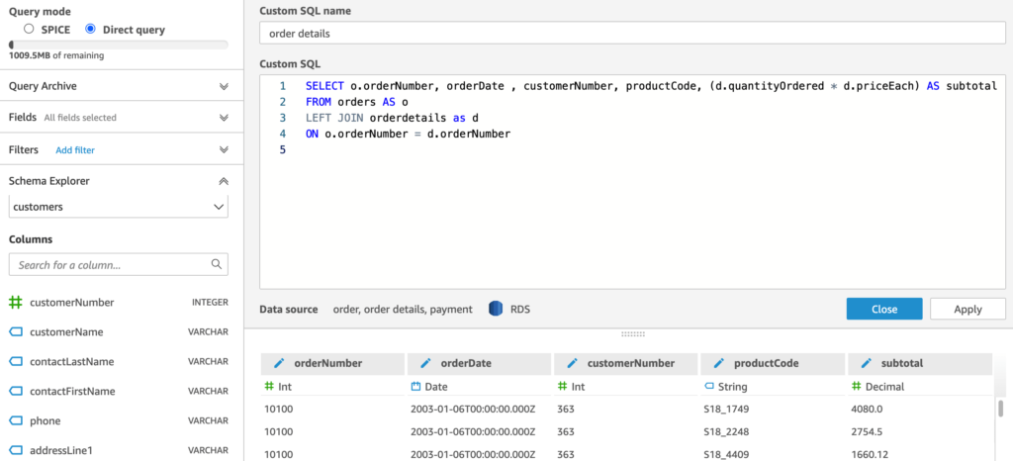

You get an SQL editor with syntax highlighting, as well as a preview of the result data set. You can format data fields, change the column titles in the result and do calculations. There’s also a query archive to see previous versions of the query. In the top left-hand corner, you’ll notice there are 2 query modes:

* **SPICE** (Super-fast, Parallel, In-memory Calculation Engine) – stores the data in memory for you so that it doesn’t have to keep querying the database each time you render a visualization. This is a great option for making your visualizations faster, especially for data that doesn’t change quickly. You can set SPICE to refresh and re-query the data on a schedule of your choosing.
* **Direct Query** is the opposite, which means it will rerun the query each time and get the data directly from the database each time.

## **Option 2: Edit/Preview Data (data workspace)**

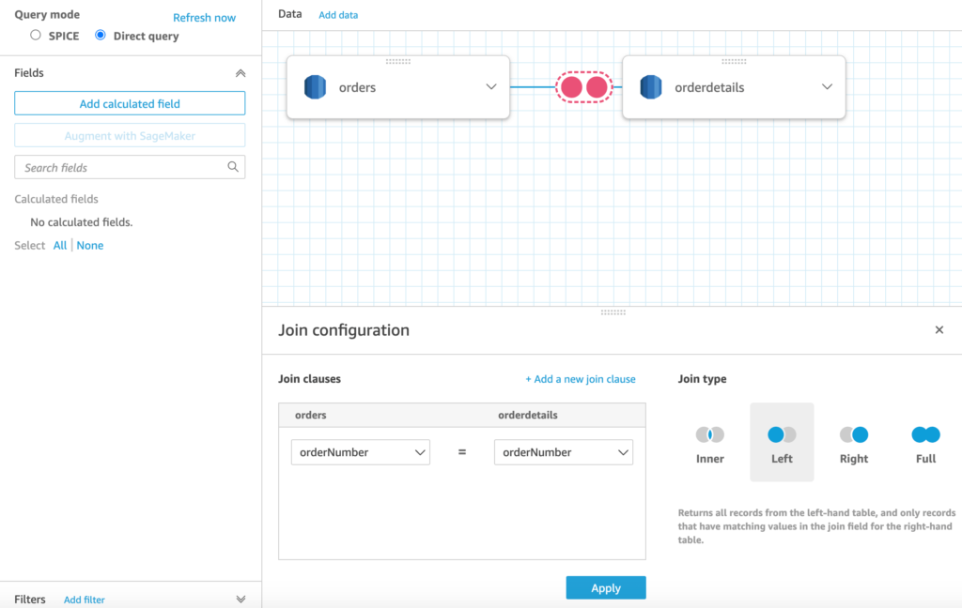

This option offers a “data workspace”, a visual representation of your database tables that provides functions for adding join clauses. This is great for doing simple queries, especially for those who are less familiar with SQL syntax. You can click “Add data” to add additional tables.

The only downside of this option is that there’s no way to switch to custom SQL mode for queries created in visual mode. (However, the opposite is possible. i.e queries created in custom SQL mode can be visualized in the data workspace)

Regardless of the option you choose, once you’re happy with your return data set, click apply and you will be taken to the data visualization area.

## **Create graphs & visualizations in quicksight**

Click Add -> Add visual to create a new visualization from your dataset.

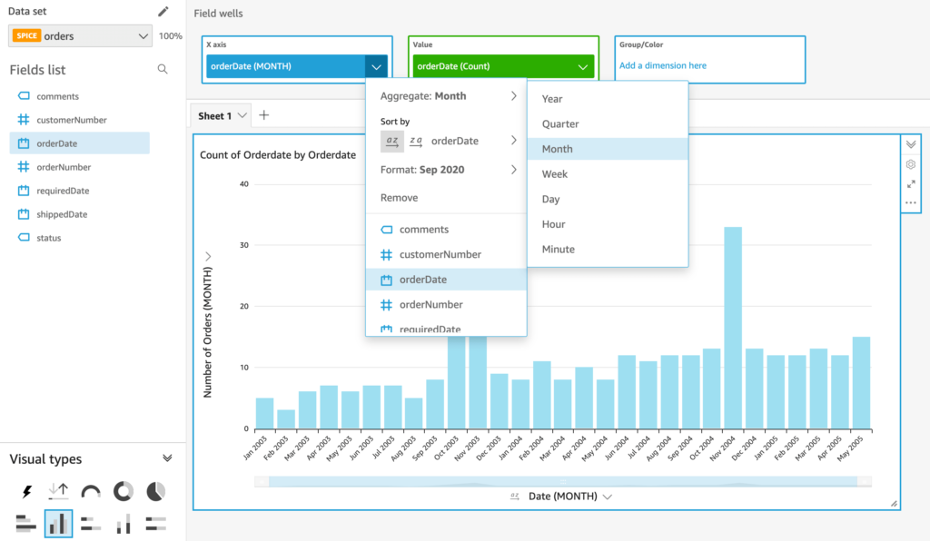

Under Visual types in the  bottom left-hand corner, select the type of graph or visualization you want to create. From the fields list, click the data fields you want to feature on your graph. You can also drag a data field to the X axis (blue) or Value (green) boxes to tell it which axis to use for each field.

To add additional datasets to graph, click on the pencil icon and add a new dataset. After adding a new dataset, it may take you to a new blank dashboard. If this happens to you, click the Quicksight icon to go back to the main area and select the analysis you were already working on.

There are also a lot of optional features for making your graphs more interactive. For example, you can create filters that would allow the user to view specific time frames of the data.

## **Publish a dashboard**

Once you’re done creating your visualizations, click on share from the upper right-hand corner and click Publish dashboard. This saves the current state of your dashboard, and allows you to invite others to view it.